# Project Documentation

## Project/Documentation: Design and Build an Enterprise Small Office Network using Cisco Packet Tracer

## Objective

## The objective of this project is to design, configure, and simulate a small office network using Cisco Packet Tracer, showcasing VLAN segmentation, inter-VLAN routing, HSRP-based redundancy, NAT configuration, and overall network security.

## Network Overview

* Devices Used: 2 MLS {MLS switch (MLS 1, MLS 2)}, 2 Switches (SW1, SW2), 6 PCs, 1 ISP Router
* Software: Cisco Packet Tracer
* VLANs: VLAN 10 (Management), VLAN 20 (Voice), VLAN 30 (Data)
* Topology: R1 and R2 configured for inter-VLAN routing and redundancy, SW1–SW2 connected via EtherChannel trunk, R2 connected to ISP via NAT, HSRP configured for gateway redundancy

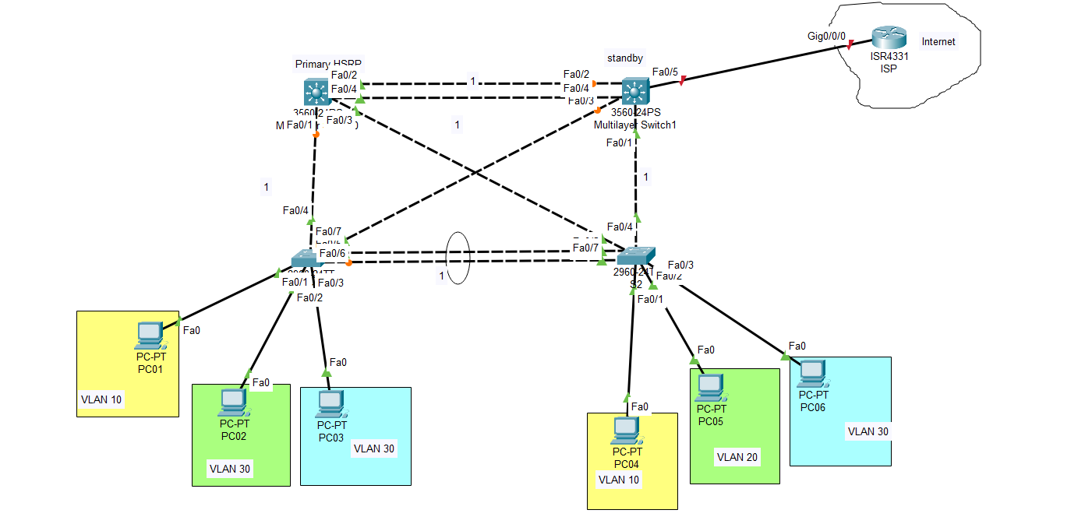

## Key Configurations

* Created VLANs 10, 20, and 30 and assigned respective ports on switches.
* Configured Inter-VLAN routing using sub interfaces {Router on stick} on routers.
* Implemented HSRP between R1 and R2 for gateway redundancy.
* Established an EtherChannel trunk between SW1 and SW2.
* Configured NAT overload on R2 for Internet access.
* Applied ACLs to secure internal networks and control traffic flow.
* Verified end-to-end connectivity and Internet access through simulations.

## Network Topology Overview{example}

|  |  |  |  |
| --- | --- | --- | --- |
| Device | Interface | IP Address | VLAN / Purpose |
| MLS1 | G0/0/0.10 | 192.168.10.1 | VLAN 10 (Mgmt) |
| MLS1 | G0/0/0.20 | 192.168.20.1 | VLAN 20 (Voice) |
| MLS1 | G0/0/0.30 | 192.168.30.1 | VLAN 30 (Data) |
| MLS2 | G0/0/0.10 | 192.168.10.2 | VLAN 10 (Mgmt) |
| MLS2 | G0/0/0.20 | 192.168.20.2 | VLAN 20 (Voice) |
| MLS2 | G0/0/0.30 | 192.168.30.2 | VLAN 30 (Data) |
| MLS1– MLS2 Interconnect | G0/0/1 ↔ G0/0/1 | 192.168.100.0/30 | Router-to-Router Link |
| MLS2–ISP | S0/1/0 ↔ S0/1/0 | 203.0.113.2 / 203.0.113.1 | WAN Connection |
| PCs | Fa0 | 192.168.10.x / 20.x / 30.x | Client Machines |

## Check/Ensure at last

Configure/check on end devices ping to check reachability.

## Outcome

Successfully built and tested a functional small office network supporting inter-VLAN communication, gateway redundancy using HSRP, and Internet access via NAT.

## Skills Demonstrated

* Network Design and Planning
* Routing and Switching Configuration
* VLAN and Subnet Management
* HSRP, NAT, and ACL Implementation
* Network Troubleshooting and Documentation